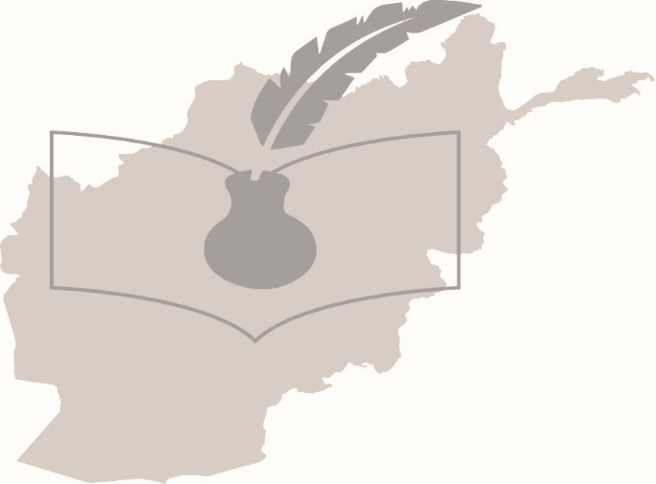  Annual Report 2019/2020 | انجمن افغانان لندن  Afghan association of london  (harrow)

Acknowledgment
It is through the sheer dedication and commitment of our staff and the growing numbers of volunteers, backed by members, supporters, partners and our generous funders that we have been able to continue with our activities and services. We would like to extend our sincere thanks to everyone who has made a contribution towards our work. Many of our projects would not be possible without this generous support. In particular, we would like to thank our current funders, The Tudor Trust, Trust for London, Community Fund & Awards for All, John Lyons Charity, Harrow School, Harrow Giving and Harrow Young Foundation and Voluntary Action Harrow for their generous support.
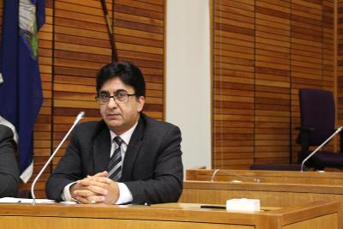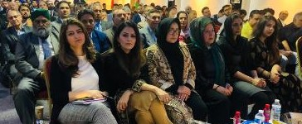
Karim Shirin, Charing a major community gathering in Harrow. This event was a great success which was organised in collaboration with our sister charities in London
Our Supporters
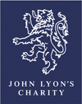
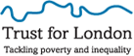
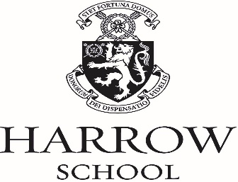

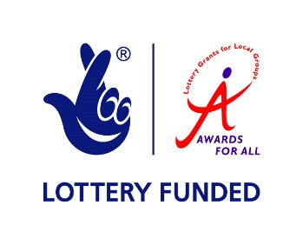


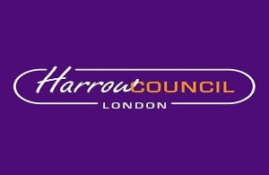
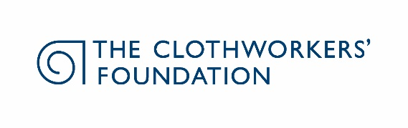


Table of Content Page:

Message from the Cahir for the Year ended 31 March 2020 4
Objectives, structure, governance and management 5

Achievements and performance 5-10

Reference and administrative information 11

Pictures of Activities and Projects 12-13

Message from the Chair for the year ended 31 March, 2020

Welcome to our 2019/2020 Annual Report, which I am delighted to introduce. 2019/2020 has been an extremely challenging year for the charity, but rewarding. The funding for three major projects namely; Advice Provision, Youth Activities and Volunteering have expired during this year but have continued on a piecemeal basis, thanks to our dedicated volunteers. Securing funding for vitally important projects in the current context is extremely challenging. We have maintained some of our projects due to the hard work, enthusiasm and professionalism of our staff, volunteers and Board of Trustee members. We are incredibly pleased with the difference that our services, projects and activities have made for our beneficiaries and the Afghan community as a whole. Our staff and volunteers provided practical support and advice to over 1500 clients. The Charity’s activities have been attended by hundreds of people. We have strengthened our joint working and partnership with key voluntary sector partners in London. We have continued with the successful Women’s project to promote social inclusion of Afghan women into UK society and completed the Women Empowerment Project. Our impressive pool of volunteers is making an enormous contribution, taking an active part in different activities, services and projects. Without our dedicated staff and volunteers, it would have been extremely difficult to continue with our services and activities. I would like to thank all our funders, partners, supporters, our dedicated volunteers and staff for their hard work. We continue with our search for resources and funding to be able to continue with the provision of our invaluable services to the community. I would like to thank the very people and organisations with whom we work, and who have helped to shape our charity.

I want to thank the Board of Trustee colleagues for their support over the past year. The contribution they make to the charity is very much appreciated and valued enormously.
Karim Shirin
Chair, Board of Trustees

Objectives, structure, governance and management
The main objectives of the Charity are to:
- To relieve poverty amongst the Afghan community in the NW London Boroughs, by the provision of an advice and interpreting service.
- To advance education amongst the Afghan community in the same areas, particularly by the provision of language classes and a library.
- To provide facilities for the recreation and other leisure-time activities for people who are in need of such facilities by reason of their social and economic circumstances with a view to improving their quality of life.
- To assist the aged, particularly those from the Afghan community; and
- To protect and preserve public health by the provision of advice.
Trustees are jointly the governing body and have ultimate responsibility for the operational administration of the Afghan Association, its premises, finances, and the employment of staff. The trustees may appoint co-opted members in order to bring specific skills and expertise to the charity.

Achievements and performance
AAL is now running a number of projects and services this section describes progress over the last year.

General Advice and Information
The Afghan Association of London was established in 1995 to assist Afghan refugees with their integration into UK society. As a centre point for the Afghan community and relevant external agencies, the Association provides a wide range of practical support, help, advice and manages a number of community projects. Since its inception, AAL has assisted thousands of Afghan refugees to successfully integrate and to make a positive contribution to British society.
More than 1500 community members have benefited from the Afghan Association’s services, activities and projects including face to face and telephone advice, youth and sport, social, educational and cultural activities and events. The Association’s services and provisions are designed to empower our community to achieve their full potential as active members of British society, to contribute to the community, and to become fully able to exercise their rights and responsibilities. We would like to address the barriers our community face, whilst promoting British and universal values, instead of encouraging a parallel existence and separation from the mainstream community. We have enhanced our partnership and working relationship with key voluntary sector charities at a local and London-wide level. We have referred clients to Harrow Law Centre. HLC staff has been extremely helpful, providing an excellent service.

Service User’s Statement and Feedback
“I am grateful for a professional service that we (myself and my family) have received from the Afghan Association and Harrow Law Centre in the last couple of years” Mr O. and family.
OISC Registration Success

The Office of Immigration Services Commissioner (OISC) has approved the Afghan Association’s application and authorised our Advice Worker to provide immigration advice and services at Level One.

Women Empowerment Project:
Anahita Fazli, Women Group Leader

Thanks to funding from Awards for All, the Afghan Association has successfully delivered the Afghan Women Empowerment Project. The Project provided a platform for Afghan women to raise their profile and to highlight their issues. The Project has encouraged Afghan women to actively participate in social, political, economic and cultural activities. As part of the project a forum has been established specifically for Afghan women to provide them with a unique opportunity to network, share experiences, concerns, aspirations and to debate and discuss key issues. A database of the participants of women events have been created for sharing information purposes. We will search for new funding to continue the Women Empowerment Project.

Volunteering
Thanks to generous funding from The Tudor Trust, the Afghan Association has established a volunteering project. The Afghan Association has benefited tremendously from the volunteering project in a number of ways: increased activity for the charity; increased variety of services, creating new projects, e.g the women’s project and sport activities; reaching out to more users; advice and support to our beneficiaries from volunteers; making users more aware of the Afghan Association’s services and activities. Volunteering is now an integral part of the Afghan Association’s service delivery. 2019/20 has been another positive year for the Afghan Association of London. The funding for the volunteering project ceased at the end of 2019. We will continue with our search for funding to continue with this vitally important project. We would like to take this opportunity to say thank you to all our hard working and dedicated volunteers.

A Big Thank You to all our volunteers

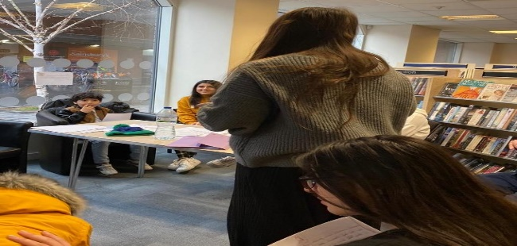
Youth activity initiated and run with the help of one of our valued volunteers.

Language Support for Afghan Doctors.
The Afghan Association continues with facilitating the Afghan Doctor’s Saturday training sessions. The training will assist Afghan Doctors to successfully pass the English language exams which are a requirement to ensure fitness to practice for all overseas doctors in the UK. These training sessions will prepare the participants to possess the language skills necessary to function effectively in an English-speaking environment.

Debating Club for Afghan Children

Dunya Amini, one of our valued volunteers who has recently graduated with a first-class degree in Law, has successfully established a debating club for Afghan youths. The first session took place in Ealing Library. Debating, no doubt is the best extracurricular activity for children to build their confidence as well as improving their public speaking skills. They will learn how to argue logically and rationally. The session was a great success with excellent feedback from participants.
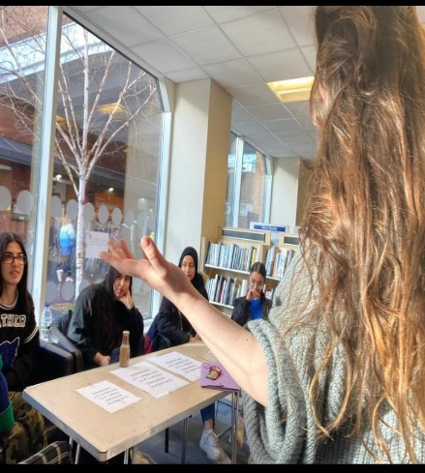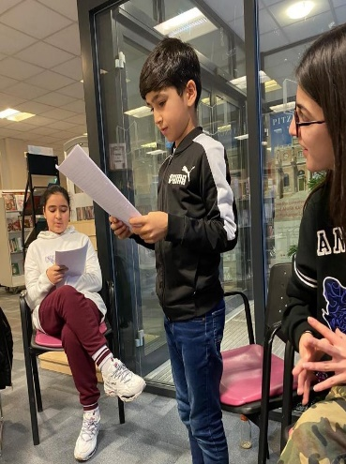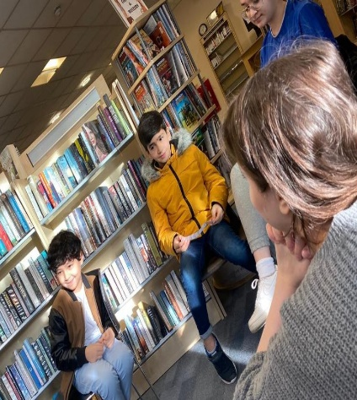
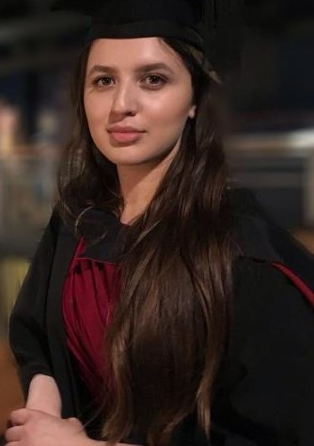
Dunya Amini
Harrow School Christmas Present
Christmas came early for a group of Afghan children and families, thanks to a generous donation in terms of vouchers and cash received from Harrow School. We are really grateful for their generosity. 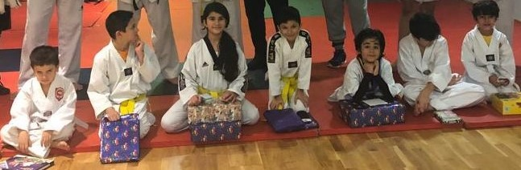 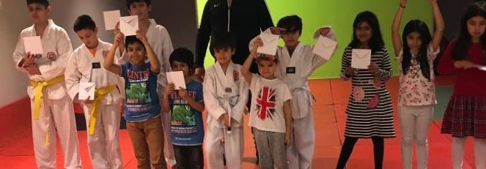 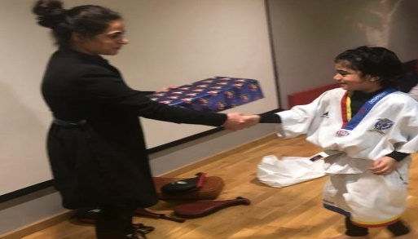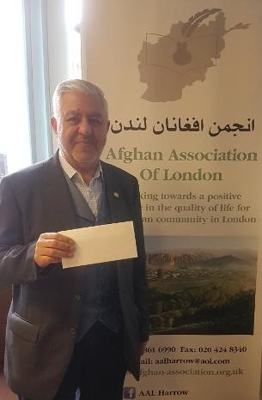

Safeguarding Training Session
In collaboration with Voluntary Action Harrow’s Safeguarding Manager, the Afghan Association has facilitated a very useful session in Harrow. The Afghan Association’s Board of Trustee members, staff and volunteers participated to improve their knowledge of Safeguarding policies to ensure a safe environment for all activities ands services. All participants were issued with Safeguarding Level 2 Certificates. We would like to thank Voluntary Action Harrow for their ongoing support.
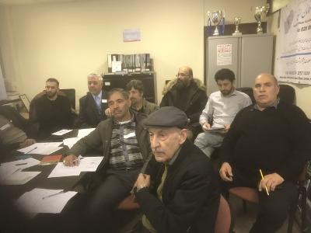

Youth and Sport Activity
We are grateful to John Lyon’s Charity for funding the Afghan Association’s Youth and Sport activities.
The Afghan youth are vulnerable and experience isolation and exclusion from different aspects of social life. They are affected by the lack of support, resources (sport and leisure facilities) and support networks. Their families are often seriously concerned about the influence of radical elements on disaffected youth which can lead to radicalisation. Many young people have difficulties settling into educational institutions and consequently fail to do as well at their studies. They, therefore, have limited employment opportunities and as a result may adopt a pessimistic outlook to life. In addition, young people are dealing with a range of issues such as lack of UK qualifications, lack of work experience, low self-esteem and confidence, little motivation or aspiration and a lack of positive role models. As a result, it’s more likely that they will feel isolated which can lead to alcohol and substance misuse and other negative tendencies such as crime and gang culture. In order to address these issues, AAL facilitates different youth and sport activities.

Football, Taekwondo, Volleyball (After School curricular activities)
Our Football team is going from strength to strength, encouraging young people to participate in sport activities, as a great way of keeping healthy and fit physically, while making new friends and having fun. Football is one of the most popular sports amongst the Afghan community. We have assisted four football managers to participate and successfully complete a coaching qualification. The feedback from participating teams is extremely positive. We would like to thank the John Lyon Charity for their generous funding and support which has enabled the Afghan Association to organise such a successful event annually for the last three years.
Sport activities will assist our young people to build up their health and self-esteem, learn the ideals of teamwork and tolerance, and be drawn away from the dangers of drugs and crime. In order to facilitate cross-cultural understanding, the Association was keen to have an inclusive approach, and draw people together, across boundaries to enjoy football. In addition, sport and football in particular, have provided an attractive distraction from negative influences. Interacting with young people from mainstream and other communities has create a perfect platform for cross-cultural communication and acceptance of differences and the importance of universal values of respect and tolerance.
John Lyon’s Charity’s funding has enabled the Afghan Association to establish a Taekwondo Club in Harrow aimed at Afghan teenagers and young adults. The Taekwondo club is one of the most successful projects in Harrow, providing excellent opportunities for 50 young people to keep fit and healthy, overcome isolation by making new friends and having fun. Sadly, funding for the youth project has expired, however we will continue with our search for funding to ensure the continuation of such a vitally important project.

Elderly Project
Thanks to funding from The National Lottery Community Fund, the Afghan Association has commenced a new project for Afghan elders. Older people are at particular risk of social isolation and disengagement and this has negative impacts on their health and well-being. The project is providing volunteering and engaging people from the Afghan community who are suffering from various forms of socio-economic exclusion. Our volunteers have successfully planned social and cultural events including the allotment project, social gatherings and a chess club.

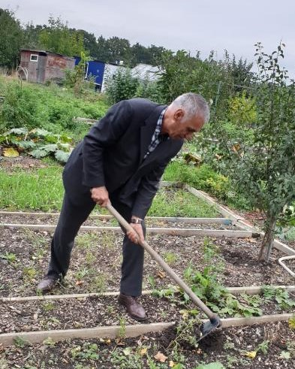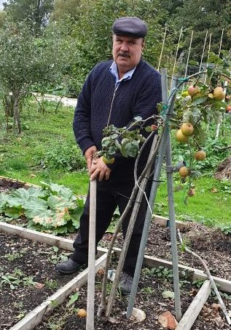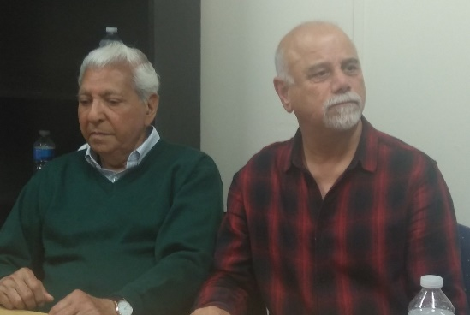

Chess Club and Chess Competition

The Chess Club meets every Monday 18:30-22:00. The Chess Club is becoming one of the most popular activities in Harrow. We have also hosted a chess competition with considerable participation.

Social Outcome for volunteers and the community:
While the volunteers bring a lot to different services, activities and projects, it is important to highlight that they have also benefited further from their volunteering experience – by helping to learn new skills, maintain and expand skills, knowledge and social networks; increase their sense of belonging to their community; and above all, by giving them a sense that they are playing a useful part in helping vulnerable members of the Afghan community.

Over 40s Football
Our volunteers have recently initiated a mini football team for over 40s. The over 40s Football team is becoming very popular with new members joining every week. The feedback from participants has been very encouraging.
We very much appreciate all the help given by our volunteers through 2019-2020 which has made such a difference to the lives of our community members. Thank you

EU Settled and Pre-Settled Status
We have facilitated a very successful joint event with Harrow Council and Harrow Law Centre and the representatives of the Afghan community who are EU citizens and are currently living in the UK. The event was very useful and informative. All EU citizens living in the UK must register with the Home Office for a new status. We have circulated the digital copies of EUSS factsheets in English together with posters to our community.

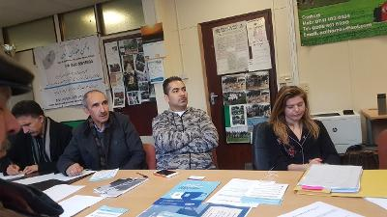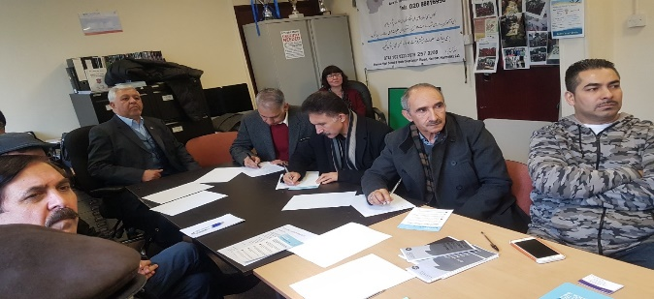
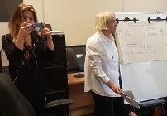
London RCO Advocacy Forum

The Afghan Association has actively participated in the London RCO Advocacy Forum, facilitated by the Refugee Council to set up a strategic forum to conduct advocacy work together with 20 other London-based Refugee Community Organisations who have been selected to be co-production partners for this project. Inviting the Afghan Association to participate in such a project is another indication of the fact that we are an important partner in London.

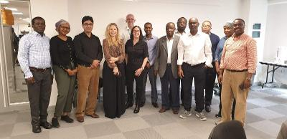

Reference and administrative information

Statement of trustee’s responsibility
The Trustees are responsible for preparing the Annual Report and the financial statements in accordance with applicable law. The Trustees prepare financial statements that provide a true and fair view of the state of affairs of the Charity, the incoming resources and application of resources including the income and expenditure of the Charity for the year.

The Trustees are responsible for keeping proper accounting records that disclose with reasonable accuracy at any time the financial position of the Charity and enable them to ensure that the financial statements comply with the Charities Act 2011, the Charity (Accounts and Reports) regulations and the provisions of the trust deed. They are also responsible for safeguarding the assets of the Charity and hence for taking reasonable steps for the prevention and detection of fraud and other irregularities.

Financial Statement
The Board of Trustees are pleased that AAL has finished the year in a relatively stable financial position. AAL has secured additional funding from Awards for All for the elderly project and overhead costs respectively. However, in the absence of core funding to cover the main operational costs of the charity, it will be a challenge to sustain the current level of activities and services. We will continue with our search for additional sources of funding.

Declaration by the Trustees
This report has been prepared in accordance with the Charities Law
By order of the Trustees:
Signed: Karim Shirin Date: 19 June 2020
Name: Karim Shirin

Pictures of activities and projects

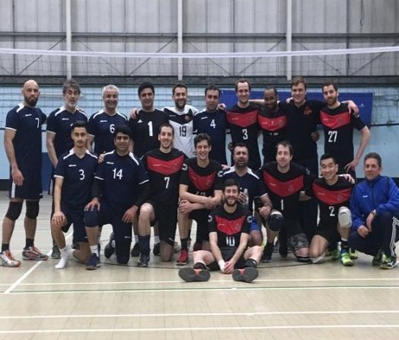 | 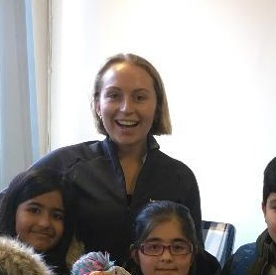 | 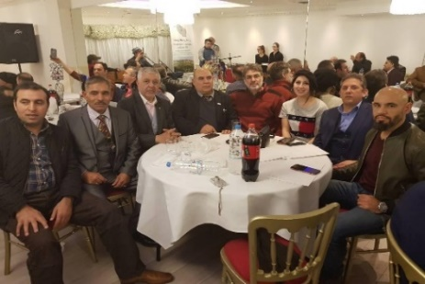
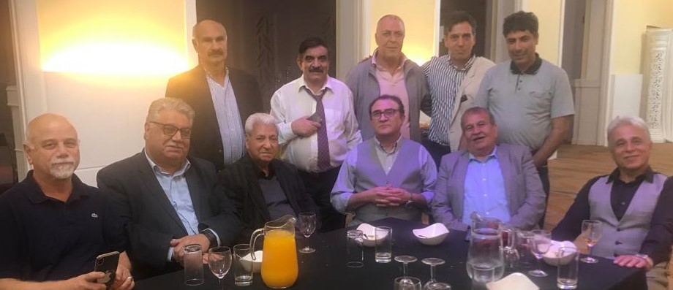 | 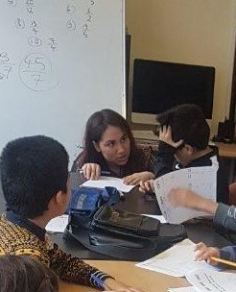 | 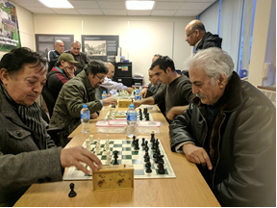
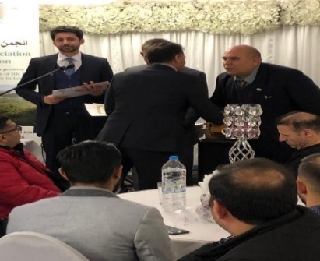 | 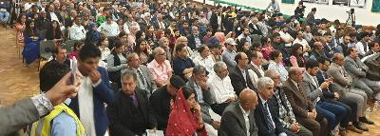 | 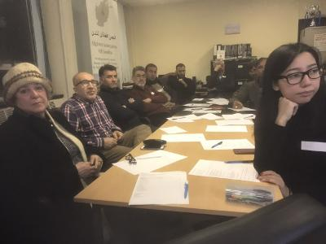

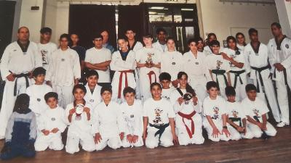 | 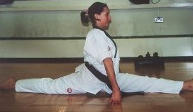 | 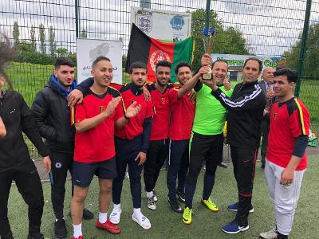
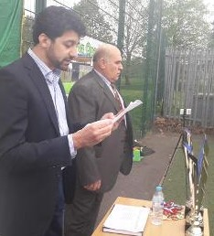 | 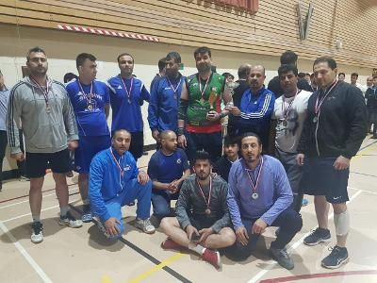 | 